vpc peering:
In simple words, vpc peering is a connection between two vpc.
rules:
1. The vpc should not contain the same IP ranges.
2. The connection of vpc's is only from one to one only.

The connection of vpc:
1. same account with the same region.
2. same account with different regions.
3. different accounts with the same region.
4. different accounts with different regions.
HANDS-ON PRACTICES:
let's try with the same account and the same region.
* Create two vpc's, subnets, and IGW, and add IGW to the routing table.
*Now deploy the instances and check if there is any connection between them.
*Now move to the peer connections and create the peer connections.
* After the creation of the peer connection send the request to the acceptance.
* add peer connection into the route with opposite IP (enter IP address in route table)and check the connections.
checking the connection(traffic) between two vpc before peer connection:
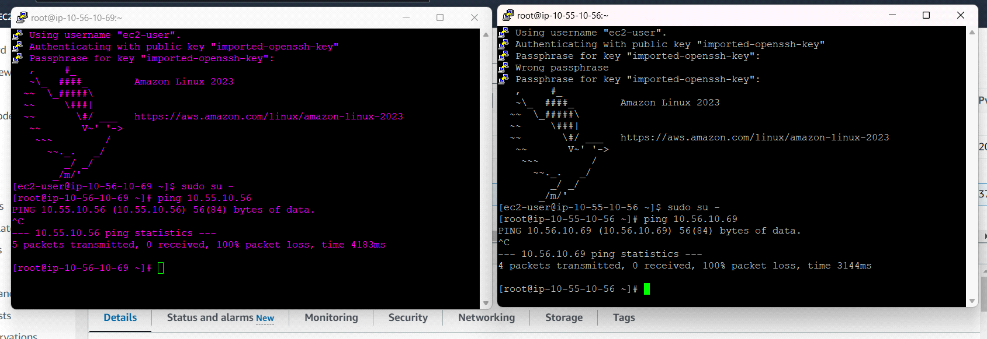
Result after peer connection:
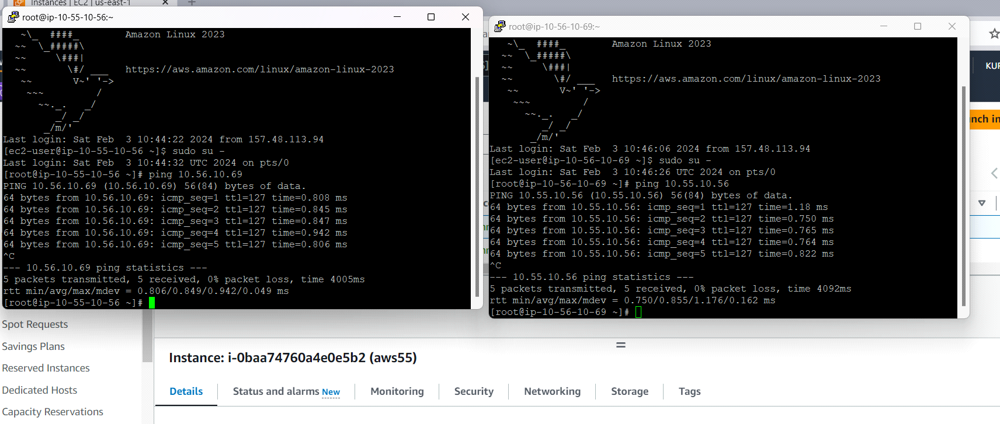
let's try with the same account and a different region:
* The process will be the same but the problem with the deployment of instance, we did not get the key -pair.
*to get the key pair log in to the instance and type ec2-metadata. copy the public key and paste the public key in key pair-->click on import (right scroll box)-->paste the public key it will import.
result :
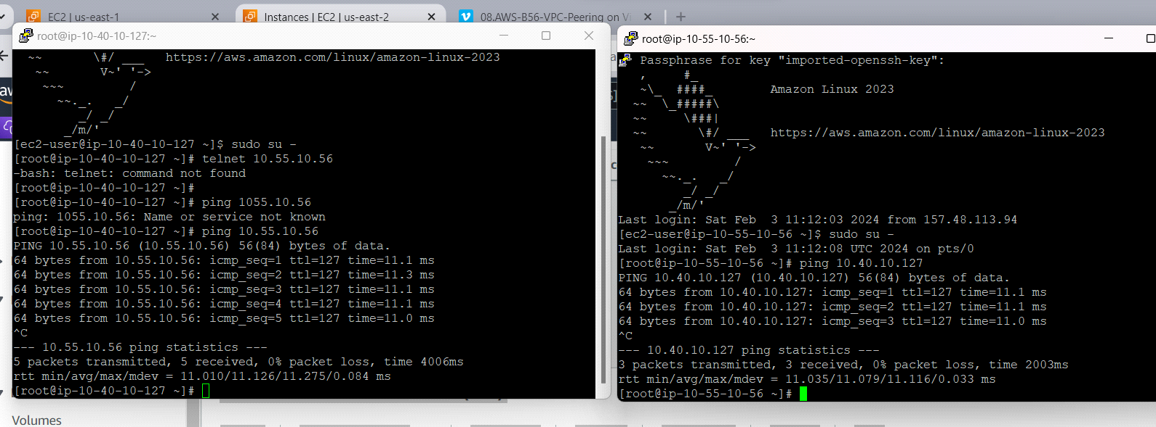

for some regions, companies will disable the ping. we can use the telnet to check the connections.
to install telnet type : yum install -y telnet. and give the port number.
example: telnet 1.56.0.0(IP address) 22(port number).

